Containers and Clouds Exam
Problems for the exam for the DevOps for Developers module @ SoftUni.

Docker Image with Terraform
Your first task is to use the "Tracker App" project and its Dockerfile (in the resources) to build and push an image to Docker Hub, using Terraform.
Create a Terraform configuration file in the app project folder:
The Terraform file should:
- Set the required Docker provider
  - Inside the provider {} block, provide authentication information (username and password) for the Docker Hub registry (registry-1.docker.io) using the registry_auth {} block
- Build a Docker image with name (registry-1.docker.io/{username}/{image-name}), build context path and tag
- Upload (push) the created Docker image to the registry to manage the image lifecycle
Apply the Terraform configuration:
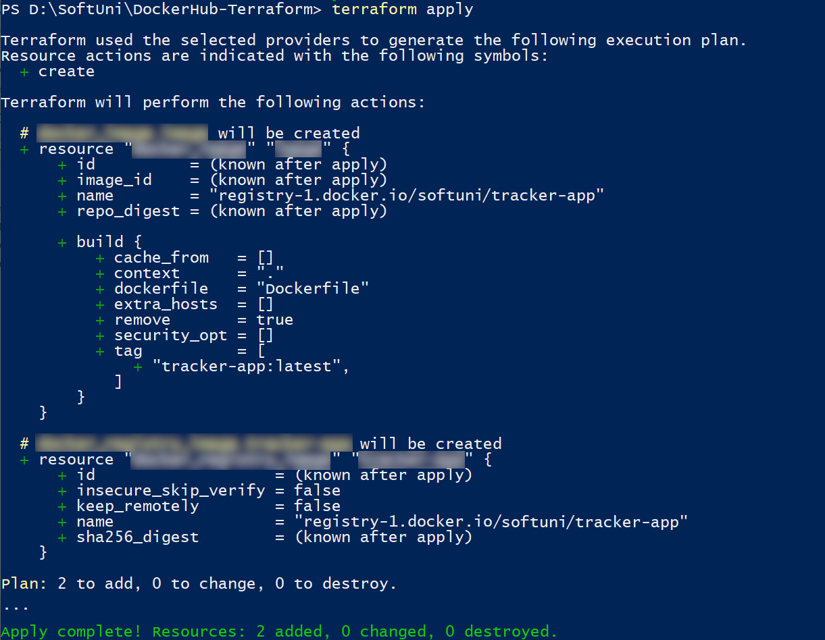
You should have your tagged image in Docker Desktop:
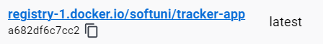
It should be pushed to Docker Hub, as well:
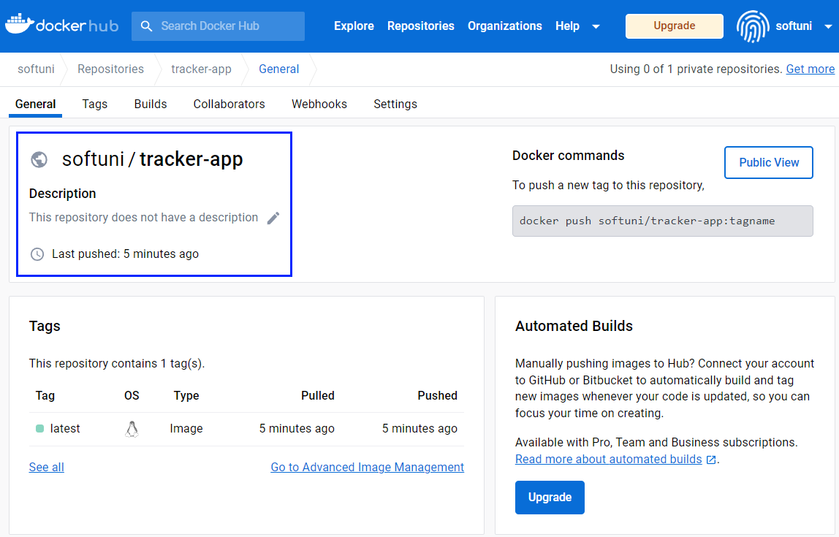
You should be able to pull and run a Docker container using this image.

Requirements
Provide the the following:
- main.tf — the Terraform configuration file used to build and push the Docker image.
- Screenshot from Docker Desktop (Images) — showing the successfully built and tagged image.
- Screenshot from Docker Hub (Repository) — showing the pushed image in your Docker Hub account.
- Screenshot of the running application — taken from the container on localhost, showing the application with at least one TODO item added using the “Add todo” functionality.
Place all of the files in a folder named {username}-task-1.

Deploy an ASP.NET Core MVC app to Azure via Terraform
You are provided with a .NET application that consists of two projects – one for the web application and one for the SQL Server database.
Your task is to deploy the app to Azure via Terraform. Deploy the app using four Terraform configuration files – main.tf, variables.tf, values.tfvars, outputs.tf.

Requirements
Provide the Terraform configuration files, the public URL of the deployed application, and a screenshot of the application's main page, accessed via the URL.
Place all of the files in a folder named {username}-task-2.

Set up App Monitoring
Set up monitoring for the deployed .NET app in Azure. You should follow the steps and instructions below.

Set up Prometheus and Blackbox Exporter (pts.)
Set the following configurations in the prometheus-exam.yml file:
- Scrape the target every 15 seconds
- Metrics should be accessed on /probe

Set up AlertManager (pts.)
Set the following configurations in the alertmanager-exam.yml file:
- Set the timeout for alert resolution for 1 minute
- Specify the webhook_receiver (use the web.hook website)
- Specify that the alerts are sent to the webhook_receiver
- Configure the alerting rules
Don't forget to change the configurations in the prometheus-exam.yml file

Requirements
Provide the alertmanager-exam.yml, alert-rules-exam.yml and prometheus-exam.yml configuration files. In addition provide the following screenshots:
- Prometheus Targets page (Status -> Target)
- Prometheus Alerts page
- Received alert in webhook.site
Place all of the files and screenshots in a folder named {username}-task-3.

Submission
Add all of the folders in an archive (.zip, .rar, .7z) and upload it to the SULS system.

